PROJECT PLAN

Our project is a quiz application that works on a webpage using JavaScript. We have developed a project plan in the form a flow chart to demonstrate how the application is implemented. The flow chart is also available in our zip file.

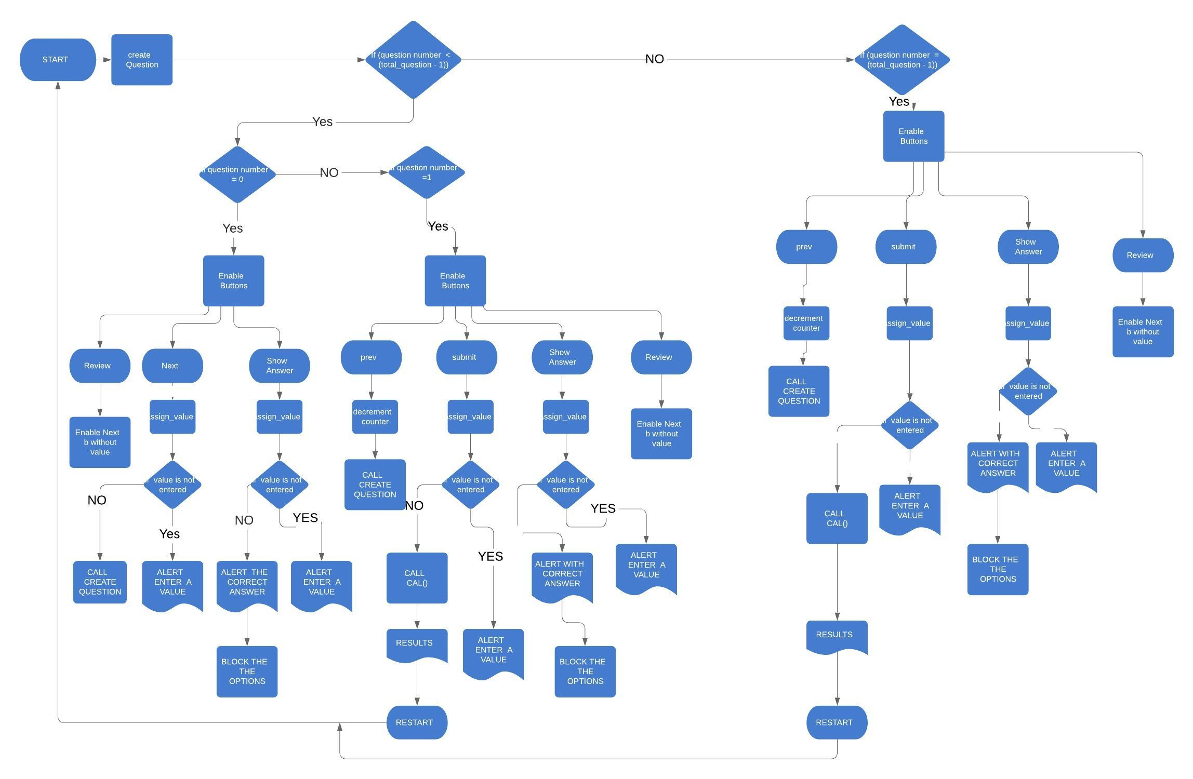

WIREFRAME:

A wireframe is a diagram used to show the layout of an application or webpage.

1. Wireframe for the starting Question of the Quiz

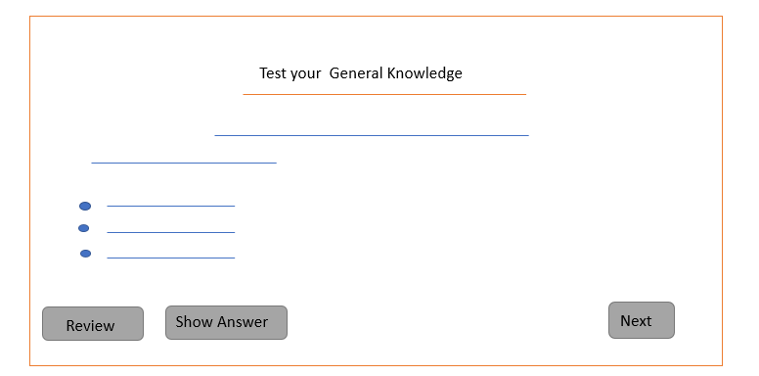

A question is asked and options are provided with the help of radio buttons placed in the same group. A user can review the question ( answer it later) and proceed to the next question. If the user does not click on the review button, he can only proceed to the next question by answering the current one.

The “show answer” button is used to show the user the correct answer in the form of an alert message, but, he is NOT allowed to change his original choice, i.e., his answer for that question gets locked once t\he “show answer” button is clicked.

1. Wireframe for the next questions: 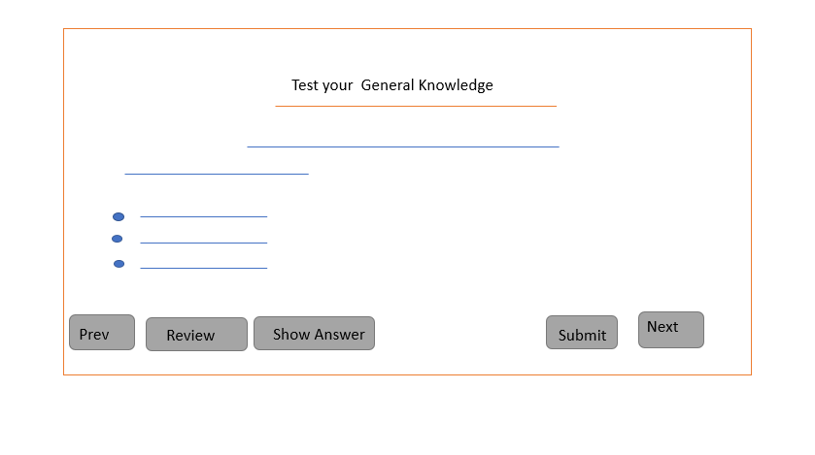

Here, the user is given the option to go to the previous question. He is also given the option to finish the quiz early , by pressing the “submit” button after answering the current question.

1. Wireframe for questions with textboxes for answer inputs:

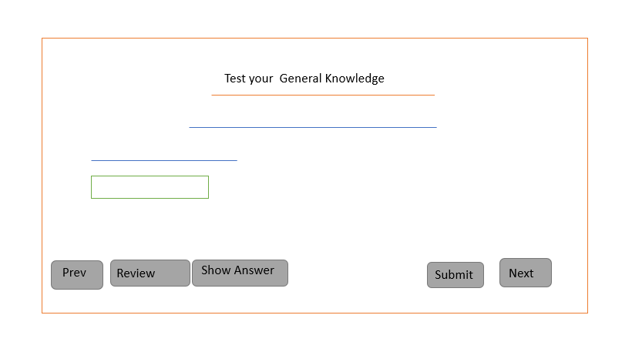

1. Wireframe for the result:

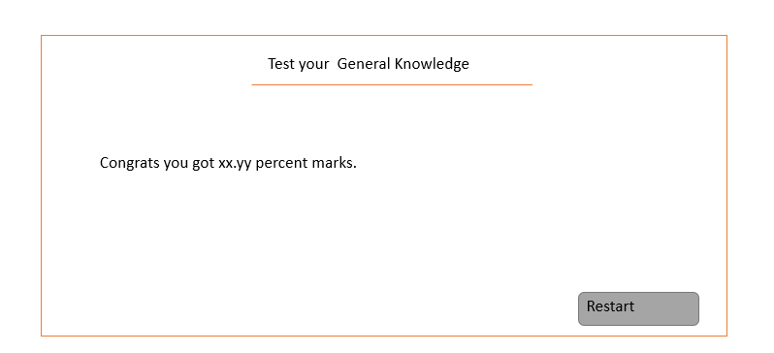

Finally, the result is displayed along with a message. If the user chooses the correct answer for more than 4 questions, he is given a “congratulations “message along with his percentage.

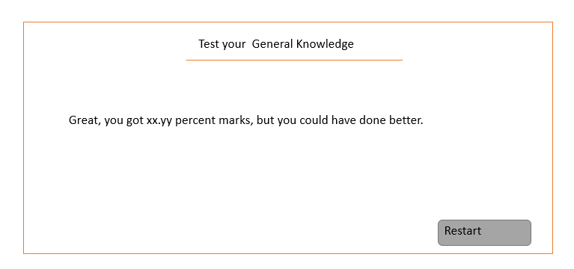

Else, he is given a “great, but you can do better“ message along with his percentage.

The Following is our html code:

<html>

<head>

<title>General Knowledge</title>

<link type='text/css' rel='stylesheet' href='Gn.css'/>

<link href="https://fonts.googleapis.com/css?family=Montserrat" rel="stylesheet">

</head>

<body>

<div id='main'>

<div id='title'>

<h1>Test your General knowledge</h1>

</div>

<br/>

<div id='gk' ></div><br>

<div class='button' id='next'>Next</div>

<div class='button' id='prev'>Prev</div>

<div class='button' id='restart'>restart</div>

<div class='button' id='submit'>Sumbit</div>

<div class='button' id='review'>Review</div>

<div class='button' id='show_answer' style = 'float : left'>Show Answer</div>

</div>

</body>

<footer>

<script src="https://ajax.googleapis.com/ajax/libs/jquery/3.3.1/jquery.min.js"></script>

<script type='text/javascript' src='js_obj.js'></script>

<script type='text/javascript' src='methods_gk.js'></script>

<script type='text/javascript' src='gk.js'></script>

</footer>

</html>

CODE FOR CSS:

ul {

list-style-type: none;

}

body {

font-family:Montserrat;

background-color:teal;

}

h1 {

text-align: center;

}

h2 {

text-align: center;

}

#question{

text-align : center-left-side;

}

#gk {

display:none;

}

.button {

border:4px solid;

border-radius:20px;

width: 40px;

padding : 5px;

position: relative;

float:right;

background-color: silver;

color: black;

margin: 2px;

}

#main {

width:90%;

margin :10% auto;

padding: 10px 40px 70px 20px;

background-color: #C36891;

border:4px round #AA1199;

border-radius:10px;

color: #FFFFFF;

font-weight: bold;

}

#prev {

float: left;

display:none;

}

#restart {

display:none;

width: 120px;

}

#show_answer{

width:110px;

}

#submit{

float: right;

width:60px;

}

#correct{

display:none;

}

#review{

float : left;

width:110px;

}

OUR JAVASCRIPT CODE HAS BEEN SPLIT IN 3 JAVASCRIPT FILES:

1. **gk.js :**

var flag = [false,false,false,false,false,false];

var flag2 = [false,false,false,false,false,false];

var count = 0;

var user_choice = [];

var gk = $('#gk');

createQuest();

$('#next').on('click', function () {

assign_value();

if (user_choice[count] == undefined) {

alert('you need to choose an option');

} else {

flag2[count] = false;

count++;

createQuest();

}

});

$('#prev').on('click', function () {

assign_value();

count--;

createQuest();

});

$('#show_answer').on('click', function () {

assign_value();

if (user_choice[count] == undefined) {

alert('you need to choose an option');

} else {

$(":text").attr("disabled", true);

$(".rad").attr("disabled", true);

flag[count] = true;

alert("Correct answer is : " + questions[count].answer);

}

});

$('#review').on('click', function () {

user_choice.splice(count, 1,"abc");

flag2[count] = true;

});

$('#submit').on('click', function () {

assign_value();

if (user_choice[count] == undefined) {

alert('you need to choose an option');

} else {

$('#question').remove();

count++;

var marksElem = cal();

gk.append(marksElem).fadeIn();

$('#next').hide();

$('#prev').hide();

$('#submit').hide();

$('#review').hide();

$('#show_answer').hide();

$('#restart').show()

}

});

$('#restart').on('click', function (e) {

window.location.reload();

});

1. **js_obj.js :**

var questions = [{

question: " What is the closest planet to the Sun? ",

options: ["Mercury", "Venus", "Earth", "Mars"],

answer: "Mercury"

}, {

question: "Which built-in method returns the calling string value converted to upper case?",

options: ["toUpperCase()", "tolowerCase()", "lcase", "hcase"],

answer: "toUpperCase()"

}, {

question: " jQuery is a cross-platform JavaScript library ",

options: [true,false],

answer: true

},{

question: " The largest known stars in our galaxy is VY Canis Majoris, ",

options: [true,false],

answer: true

}, {

question: " 3/4th of the total mass of the Sun is made up of ",

answer: "hydrogen"

}, {

question: " 1/4th of the total mass of the Sun is made up of ",

answer: "helium"

}];

1. **methods_gk.js**

function assign_value() {

if(flag[count] == false && flag2[count] === false ){

if (count <= 3){

var abc = $('input[name="ans"]:checked').val();

var xyz = questions[count].options[abc];

user_choice.splice(count, 1,xyz);

}

else if(count > 3){

user_choice.splice(count, 1,$('input[name="ans"]').val().toLowerCase());

}

}

}

function cal() {

var numb = 0;

var marks = $('<p>',{id: 'question'});

for (var i = 0; i < user_choice.length; i++) {

if (user_choice[i] == questions[i].answer) {

numb++;

}

}

if (numb < 4){

marks.append('Great, You got ' + ((numb/questions.length)*100) + ' percent marks but you could have done better');

}else if (numb >= 4){

marks.append('congrats you got ' + ((numb/questions.length)*100) + ' percent marks');

}

return marks;

}

function createQuest() {

gk.slideToggle(function() {

$('#question').remove();

if(count < (questions.length-1)){

var concat = $('<div>', {

id: 'question'

});

var head = $('<h2> General knowledge Question no ' + (count + 1) + ' :</h2>');

concat.append(head);

var para = $('<p>').append(questions[count].question);

concat.append(para);

if(count <= 3 ){

var mcq = $('<ul >');

var k;

var x = '';

for (var i = 0; i < questions[count].options.length; i++) {

k = $('<li>');

if (flag[count] == true ){

x = '<input type="radio" disabled = true name="ans" style = "vertical-align: baseline;" value=' + i + ' />';

}else if(flag[count] == false ){

x = '<input type="radio" name="ans" class = "rad" style = "vertical-align: baseline;" value=' + i + ' />';

}

x += questions[count].options[i];

k.append(x);

mcq.append(k);

}

concat.append(mcq);

}

else if (count > 3 || count < 7){

var input = document.createElement("input");

input.type = "text";

input.name = "ans";

input.autocomplete="off";

if(flag[count] == true){

input.disabled = true;

}else{

input.disabled = false;

}

concat.append(input);

}

$('#next').show();

gk.append(concat).slideDown("slow");

if(count === 1){

$('#prev').show();

$('#submit').show();

$('#show_answer').show();

}else if(count === 0){

$('#submit').hide();

$('#show_answer').show();

$('#prev').hide();

$('#restart').hide();

}

}else if (count == (questions.length -1)){

var concat = $('<div>', {

id: 'question'

});

var head = $('<h2> General knowledge Question no ' + (count + 1) + ' :</h2>');

concat.append(head);

var para = $('<p>').append(questions[count].question);

concat.append(para);

if(count <= 3 ){

var mcq = $('<ul >');

var k;

var x = '';

for (var i = 0; i < questions[count].options.length; i++) {

k = $('<li>');

if (flag[count] == true ){

x = '<input type="radio" disabled = true name="ans" style = "vertical-align: baseline;" value=' + i + ' />';

}else if(flag[count] == false ){

x = '<input type="radio" name="ans" class = "rad" style = "vertical-align: baseline;" value=' + i + ' />';

}

x += questions[count].options[i];

k.append(x);

mcq.append(k);

}

concat.append(mcq);

}

else if (count > 3 || count < 7){

var input = document.createElement("input");

input.type = "text";

input.name = "ans";

input.autocomplete="off";

if(flag[count] == true){

input.disabled = true;

}else{

input.disabled = false;

}

concat.append(input);

}

gk.append(concat).slideDown("slow");

$('#next').hide();

$('#submit').show();

}

});

}